Parallel Lines in Solid Geometry

Definition
# Source: AI Source: Provided by: [Data Path: Persons Table -> ID Column: 1, Name_En Column: Motasem Essam] -> From: [ChatGPT] on [7/25/2026]
Parallel lines in solid geometry are distinct straight lines in three-dimensional space that lie in the same plane and never intersect, regardless of how far they are extended.
Two lines are parallel when they have the same direction, meaning their direction vectors are scalar multiples of each other, and they represent different lines.
For lines with direction vectors $d_{1}$ and $d_{2}$, the parallelism condition is
$$d_{2}=kd_{1}, k≠0$$
The lines must also be distinct rather than coincident.

Simple Definition
# Source: AI Source: Provided by: [Data Path: Persons Table -> ID Column: 1, Name_En Column: Motasem Essam] -> From: [ChatGPT] on [7/25/2026]
Parallel lines are straight lines that extend infinitely in the same or opposite directions while remaining the same perpendicular distance apart.
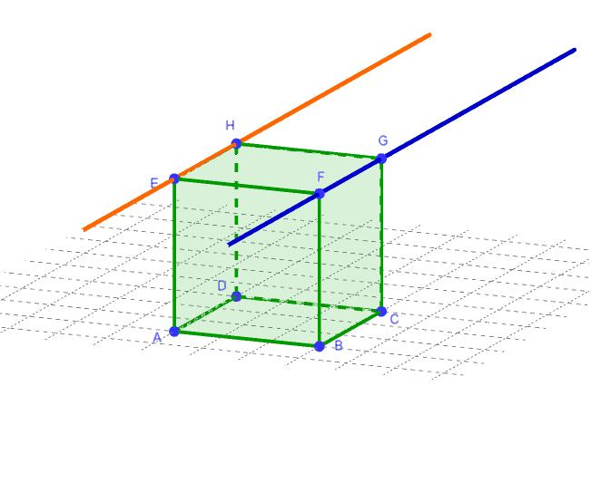
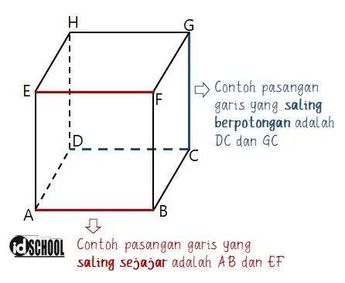
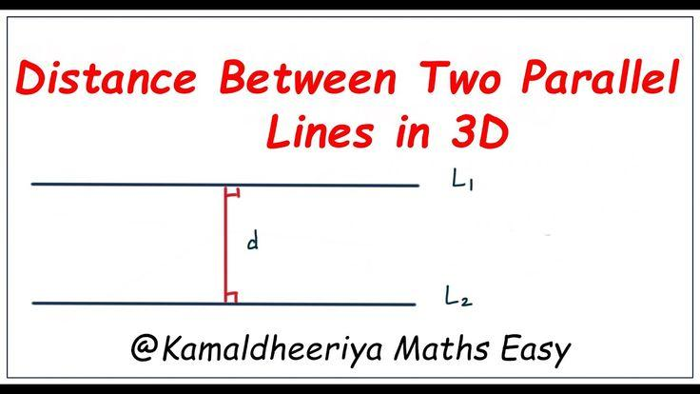
Examples include opposite edges of a cube, the two straight rails of a railway track in an idealized model, and two lines drawn in the same plane that never meet.

Key Characteristics
# Source: AI Source: Provided by: [Data Path: Persons Table -> ID Column: 1, Name_En Column: Motasem Essam] -> From: [ChatGPT] on [7/25/2026]
- Same direction: Their direction vectors are scalar multiples of each other.
- Never intersect: Distinct parallel lines do not share a point.
- Coplanar: Both lines lie in a common plane.
- Constant separation: The perpendicular distance between them remains constant.
- Infinite extent: Both lines extend without end in both directions.
- May occupy different positions: Parallel lines do not need to lie on the same face of a solid; they may lie in different parallel planes.

Types and Examples of Parallel Lines in Solid Geometry

1. Parallel Lines in a Coordinate Plane
# Source: AI Source: Provided by: [Data Path: Persons Table -> ID Column: 1, Name_En Column: Motasem Essam] -> From: [ChatGPT] on [7/25/2026]
Two lines may be parallel within a coordinate plane, such as the $xy$-plane.
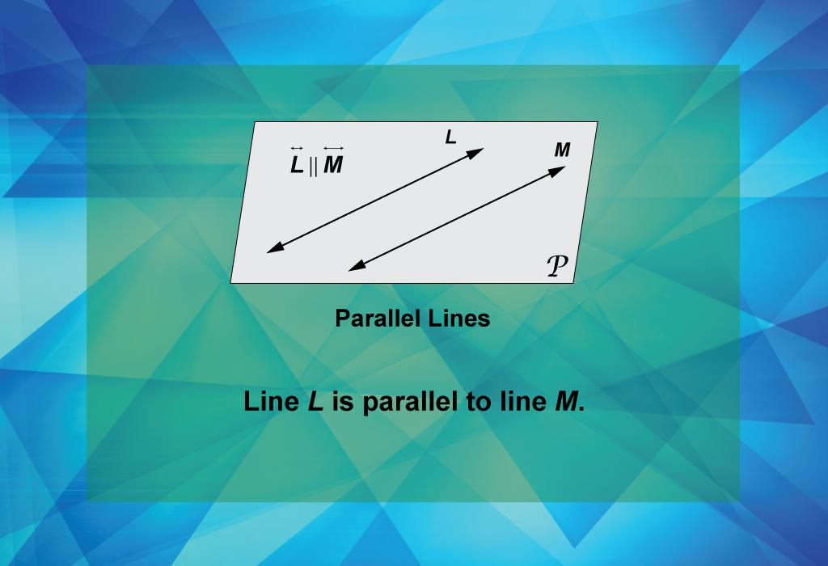
For example,
$$\begin{aligned}L_{1}&:y=2x+1 \\ L_{2}&:y=2x+5\end{aligned}$$
Both lines have slope $2$, but different intercepts. Therefore, they are distinct parallel lines.

2. Parallel Lines Along a Solid's Edges
# Source: AI Source: Provided by: [Data Path: Persons Table -> ID Column: 1, Name_En Column: Motasem Essam] -> From: [ChatGPT] on [7/25/2026]
A cube or cuboid contains several pairs of parallel edges.
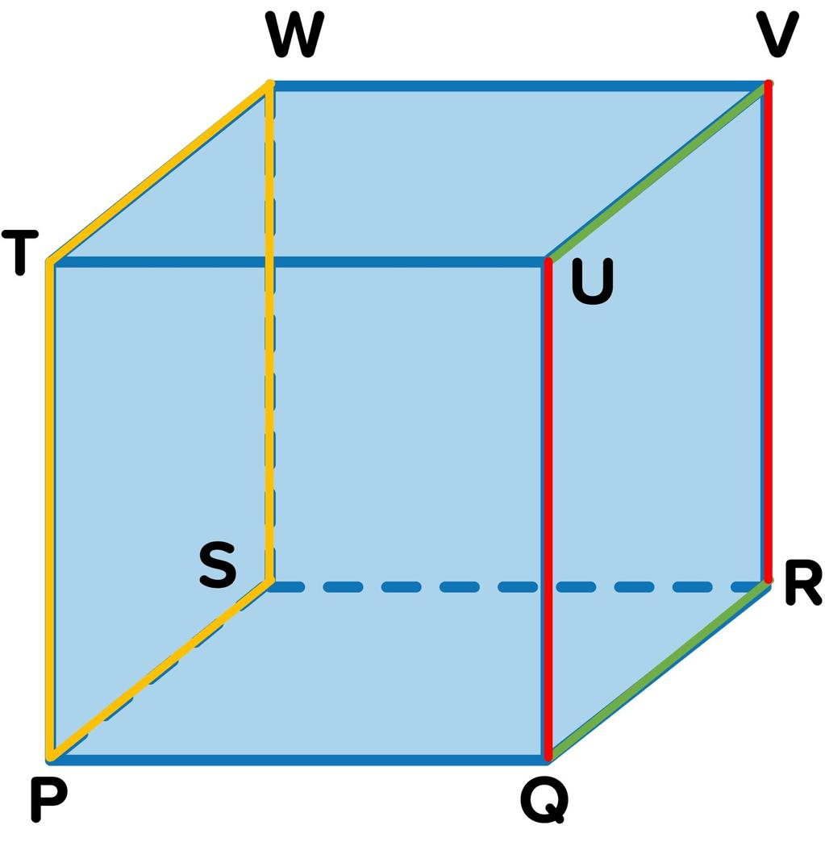
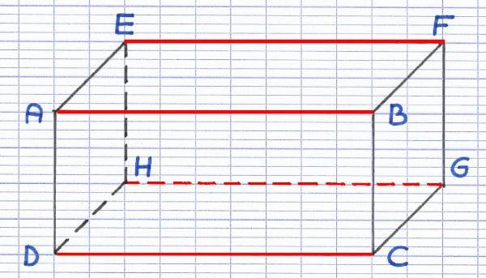
For a cube, the 12 edges form three groups of four mutually parallel edges. Each group follows one of the three perpendicular coordinate directions when the cube is aligned with the coordinate axes.
For a cuboid, edges in the same direction are parallel and have equal lengths.

3. Parallel Lines at Different Positions in Space
# Source: AI Source: Provided by: [Data Path: Persons Table -> ID Column: 1, Name_En Column: Motasem Essam] -> From: [ChatGPT] on [7/25/2026]
Two parallel lines can have different coordinates and lie on different planes while sharing the same direction.
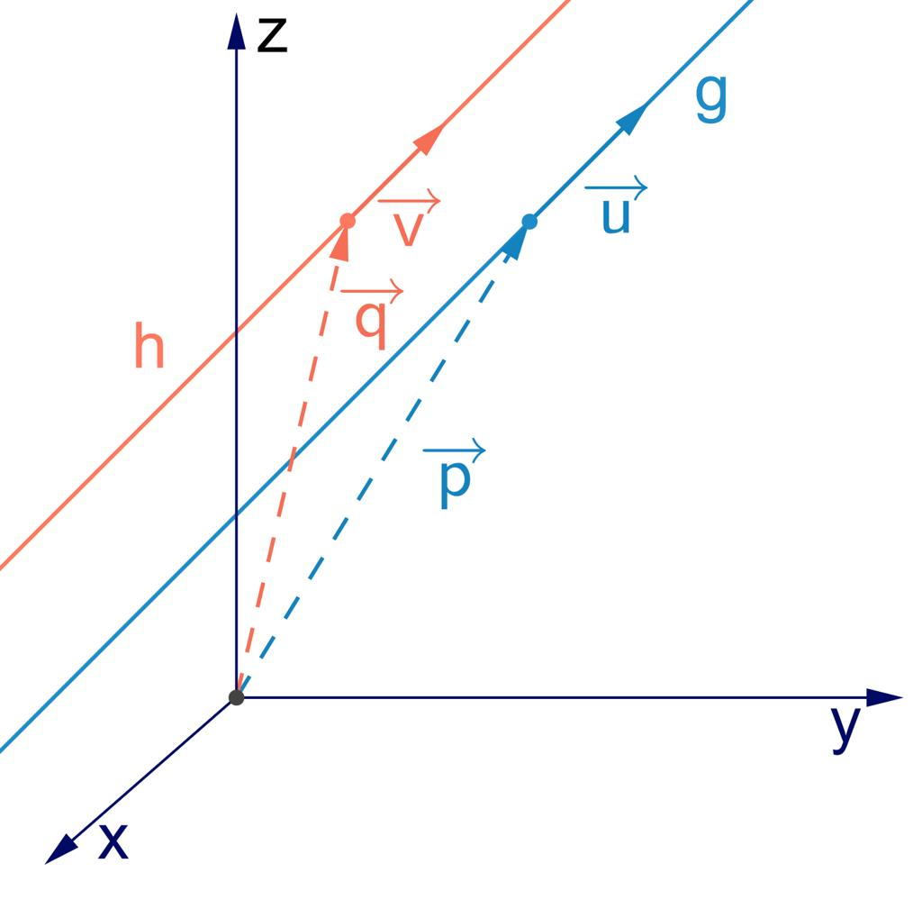
Consider
$$L_{1}=\left(t,0,0\right), t∈R$$
and
$$L_{2}=\left(t,3,4\right), t∈R$$
Both lines have direction vector $\left(1,0,0\right)$. They are distinct and separated by the constant perpendicular distance
$$d=\sqrt{3^{2}+4^{2}}=5$$
Therefore, they are parallel.

4. Parallel Lines Versus Coincident Lines
# Source: AI Source: Provided by: [Data Path: Persons Table -> ID Column: 1, Name_En Column: Motasem Essam] -> From: [ChatGPT] on [7/25/2026]
Coincident lines occupy exactly the same geometric position. Although their direction vectors are parallel, they are not considered distinct parallel lines under the usual Euclidean definition.
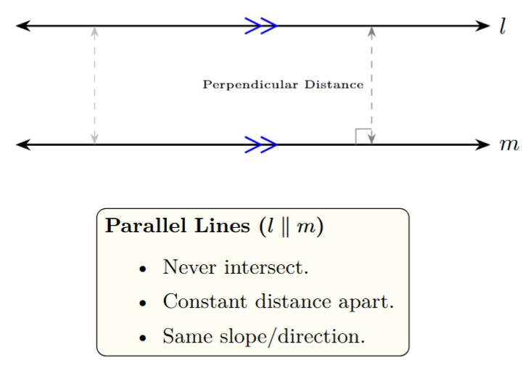
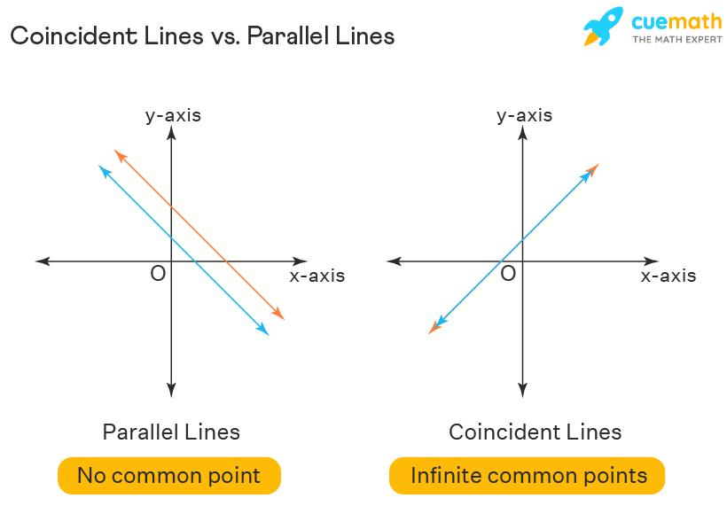
- Parallel lines: Different positions, same direction, no intersection.
- Coincident lines: Same position; every point on one line also lies on the other.

6. Mathematical Representation

1. Vector form
# Source: AI Source: Provided by: [Data Path: Persons Table -> ID Column: 1, Name_En Column: Motasem Essam] -> From: [ChatGPT] on [7/25/2026]
A line in three-dimensional space can be represented as
$$L_{1}:r=a+td_{1}$$
$$L_{2}:r=b+sd_{2}$$
where $a,b$ are position vectors and $d_{1},d_{2}$ are nonzero direction vectors.
The lines have parallel directions if
$$d_{2}=kd_{1}, k≠0$$
For them to be distinct parallel lines, they must not be the same geometric line.

2. Parametric form
# Source: AI Source: Provided by: [Data Path: Persons Table -> ID Column: 1, Name_En Column: Motasem Essam] -> From: [ChatGPT] on [7/25/2026]
For a line passing through $\left(x_{0},y_{0},z_{0}\right)$ with direction vector $\left(a,b,c\right)$,
$$\begin{aligned}x&=x_{0}+at \\ y&=y_{0}+bt \\ z&=z_{0}+ct\end{aligned}$$
Two lines have parallel directions if their direction vectors are proportional.
For example,
$$L_{1}=\left(1,2,3\right)+t\left(2,4,6\right)$$
$$L_{2}=\left(0,0,1\right)+s\left(1,2,3\right)$$
Their direction vectors are proportional because
$$\left(2,4,6\right)=2\left(1,2,3\right)$$
The lines are distinct, so they are parallel.

3. Perpendicular distance between parallel lines
# Source: AI Source: Provided by: [Data Path: Persons Table -> ID Column: 1, Name_En Column: Motasem Essam] -> From: [ChatGPT] on [7/25/2026]
If two parallel lines have a common direction vector $d$, and position vectors $a$ and $b$ for points on the respective lines, their perpendicular distance is
$$D=\frac{\left\|\left(b-a\right)×d\right\|}{\left\|d\right\|}$$
Here, $×$ denotes the vector cross product. This formula measures the shortest distance between the two lines.

Interactive Visualization
# Source: AI Source: Provided by: [Data Path: Persons Table -> ID Column: 1, Name_En Column: Motasem Essam] -> From: [ChatGPT] on [7/25/2026]
Explore how two distinct parallel lines can keep the same slope while changing their positions.
-8-6-4-22468-6-4-224xy
Reference
$$y=0.6x+0$$
Comparison
$$y=0.6x+3$$
Different y-intercepts make the two lines parallel
$$b_{2}$$
Give feedback
Changing a line's intercept moves it without changing its direction. When both intercepts become equal, the lines coincide instead of remaining distinct parallel lines.

Worked Examples
# Source: AI Source: Provided by: [Data Path: Persons Table -> ID Column: 1, Name_En Column: Motasem Essam] -> From: [ChatGPT] on [7/25/2026]
Example 1: Determine whether two lines are parallel
Given the direction vectors
$$d_{1}=\left(2,3,4\right), d_{2}=\left(4,6,8\right)$$
Check whether one is a scalar multiple of the other:
$$d_{2}=2d_{1}$$
The direction vectors are proportional, so the lines have parallel directions. If the lines are distinct, they are parallel.
Example 2: Find the distance between two parallel lines
Consider
$$L_{1}=\left(t,0,0\right)$$
$$L_{2}=\left(t,6,8\right)$$
Both lines extend in the $x$-direction. Their perpendicular separation is
$$D=\sqrt{6^{2}+8^{2}}=\sqrt{100}=10$$
Answer: The distance between the lines is $10$ units.
Example 3: Parallel or intersecting?
Consider
$$L_{1}=\left(0,0,0\right)+t\left(1,2,0\right)$$
$$L_{2}=\left(1,0,0\right)+s\left(1,2,0\right)$$
Their direction vectors are identical, so they have parallel directions. To check whether they coincide, compare the displacement between their starting points, $\left(1,0,0\right)$, with their common direction $\left(1,2,0\right)$.
These vectors are not scalar multiples. Therefore, the lines are distinct and parallel.

Relationships Between Lines in Space
# Source: AI Source: Provided by: [Data Path: Persons Table -> ID Column: 1, Name_En Column: Motasem Essam] -> From: [ChatGPT] on [7/25/2026]
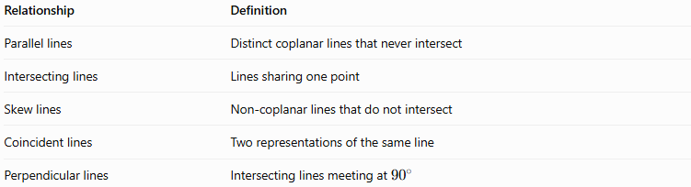
Relationship | Definition
Parallel lines | Distinct coplanar lines that never intersect
Intersecting lines | Lines sharing one point
Skew lines | Non-coplanar lines that do not intersect
Coincident lines | Two representations of the same line
Perpendicular lines | Intersecting lines meeting at ${90}^{∘}$
An important distinction in solid geometry is that two lines can have proportional direction vectors without being identical. To establish that they are parallel rather than coincident, their positions must also be checked.

Applications
# Source: AI Source: Provided by: [Data Path: Persons Table -> ID Column: 1, Name_En Column: Motasem Essam] -> From: [ChatGPT] on [7/25/2026]
- Architecture: Designing parallel walls, beams, and structural edges.
- Engineering: Aligning shafts, rails, and mechanical components.
- 3D modeling: Defining repeated edges and parallel features.
- Computer graphics: Determining object orientations and spatial relationships.
- Coordinate geometry: Testing whether lines have proportional direction vectors.
- Construction: Maintaining consistent spacing between straight structural elements.

Key Points
# Source: AI Source: Provided by: [Data Path: Persons Table -> ID Column: 1, Name_En Column: Motasem Essam] -> From: [ChatGPT] on [7/25/2026]
- Parallel lines are distinct, coplanar lines that never intersect.
- Their direction vectors are nonzero scalar multiples of one another.
- Parallel lines can lie in different positions and at different coordinates.
- Their shortest perpendicular distance remains constant.
- Coincident lines have the same direction but occupy the same geometric position.
- In three-dimensional space, non-intersecting lines are not necessarily parallel; they may be skew lines.

Conclusion
# Source: AI Source: Provided by: [Data Path: Persons Table -> ID Column: 1, Name_En Column: Motasem Essam] -> From: [ChatGPT] on [7/25/2026]
Parallel lines in solid geometry are distinct straight lines that share the same direction, lie in a common plane, and never intersect. They occur in coordinate geometry, on the edges of solids, and in many three-dimensional structures. Direction vectors provide a reliable mathematical method for identifying parallel lines, while position and distance distinguish them from coincident and skew lines.

